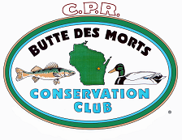
Friends of Terrell’s Island 2018
Membership Application

I would like to give my support for the Butte des Morts Conservation Club!
Please accept my membership today in the following amount:

 $25 (individual) $30 (family) $50 $100 $250 $500 $1,000 (Lifetime)
Other $____________

The BDMCC is a 501(c)(3) nonprofit organization. Contributions may be tax deductible.
Please print your information below.  _______________________________________________________  Name  _______________________________________________________  Street Address  _______________________________________________________  City, State and Zip Code  _____________________________________________________________  Phone  ___ ____________________________________________________________  E-mail  *Your e-mail is how we communicate our newsletter & events | Please make checks payable to BDMCC and send to:  BDMCC  P.O. Box 385  Butte des Morts, WI 54927

(For Club Use)
Date Received_________________ _________Entered - Secretary / Date__________
Received by___________________ _________ Entered - Treasurer / Date__________
_________ Entered - Roster / Date __________
Comments:

